Beyond BoundarieS
2014 Summer Update, Review and proposal

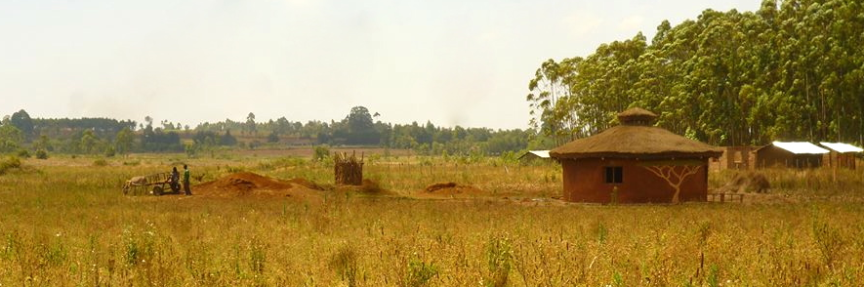

BEYOND BOUNDARIES & THE GLOBAL VILLAGE COUNCIL HUT INITIATIVE (CHI)

In the summer of 2012 the Scheerer Foundation granted $25,000 to Beyond Boundaries (BB), towards the Council House Initiative. The intergenerational team of BB responds to requests from a growing local and global community of projects and people working for a regenerative and peaceful future, within the USA and around the world. We operate with an ethic of service, co-creative learning and cross-cultural collaboration, practice of deep listening and bearing witness, responding to calls for collaboration and compassionate action.

The Council Hut Initiative was thus born in 2011. The vision of The Global Village Council House Initiative is to create an interconnected, intergenerational, worldwide community of council-carrying peacemakers with the knowledge and energy to build beautiful, round, human-scale, sacred shelters made from the Earth. This is a contribution to the growing reality of an interconnected, healthy world culture with respect for and “beyond boundaries” of race, culture and nationality.

After creating the first hut, the ‘Heron Hut’, in California in 2011, BB was invited to build a ‘peace hut’ with International Peace Initiatives in Kenya. After a time of building relations, research and planning, in 2012, a small team traveled to Kenya to guide the process – building community and a peace hut as a next step in the dream. Cross-cultural practical education in ecological building techniques, paired with community practices and coming together in council, resulted in a round house - an ideal space for honest, heartful communication. In the winter of 2013, one of our younger team members and earth-bag-builder-in-training, Siri Gunnarson, returned to Kenya to build a second peace hut with another grassroots project in Kenya: OTEPIC. She was joined by two of the Kenyans who co-built the peace hut at IPI, who were supported to take leadership and responsibility for this next step in this new cross-tribal collaboration in their own country. She also returned to IPI and offered follow up council trainings for the staff initially trained in 2012.

CHI has received invitations for future projects, in Liberia, Brazil and the USA. In 2012, we began to explore the possibility to build a hut with Grandmother Margaret Behan (formerly of The Council of 13 Indigenous Grandmothers) on the Northern Cheyenne reservation in Montana. With this, we reached out to the Scheerer Foundation, and were generously granted $20,000 towards building the next Council Hut.

With Grandmother Margaret, the process of building relations, research and planning have continued since 2012. Due to a number of unforeseen changes and challenges, we have found the process has required careful time and attention. In fall 2013, on the invitation of Gigi Coyle, BB founder, a six-person intergenerational team hosted Grandmother Margaret (GM) at The Ojai Foundation. Her time there included a public talk on reconciliation and the trauma of American history with First Nations peoples. Through a series of meetings, it was co-determined that it is not yet time to plan a building project.

The key issues we have discovered are 1) GM has not yet been able to purchase the land of the proposed building site, 2) she is Southern Cheyenne working in Northern Cheyenne territory and there is much discord between the 2 i.e. tribal politics, and 3) there are still significant issues with women’s leadership within the tribes and GM is under a lot of pressure and criticism from some tribal members . We feel these issues need to be given attention more than the building at this point and are offering some assistance regarding this . It continues to be important to move slowly and it is unclear when, or if, the issues will yield readiness to build a Council Hut. As a next step, in 2015-2016 one to three Beyond Boundarians will travel to Montana, to continue the process, by request and invitation, to meet with tribal elders and explore if/when/how it may be right to further this project, or what other role we may have in supporting the work on the reservation.

OUR PROPOSAL
With the unknowns regarding the CHI project with Grandmother Margaret, we have used only a small portion of the funds allocated for 2013-2014for CHI/GM. ($2,300 to cover her travel and expenses for our program in Ojai ). We feel that given the unpredictability of the situation and the potential inability to resolve the issues named above, it would be beneficial to reallocate at least some of the grant funds toward other BB projects where there is a current readiness for collaboration and manifestation. Here, we offer a proposal for how $10,000 may be redistributed into the wider frame of Beyond Boundaries work, leaving $10k available should the work with GM resolve, or for future reallocation, as co-determined. (A longer 2014 report and proposal are available if you are interested.)
At present, we propose to use $10,000 towards the following projects:
- $1,400, for three to travel to Montana to follow up with Grandmother Margaret.
- $1,500, for design and development of our website, the next step for sharing our stories, fundraising, and raising awareness for our work beyond boundaries.
- $3,500, for Walking Water, a pilgrimage between the Owens Valley and Los Angeles, walking for the healing of the relationship between people and water in CA and around the world
- $1,000, for ongoing interface and volunteer projects with the Owens Valley Paiute tribe and their community garden and local concerns.
- $1,300, for a plane ticket for one team member to go to the New Story Summit in Findhorn, Scotland.
- $1,300 for a plane ticket to Kenya for further council trainings.

GRATITUDE
We give thanks for the gift already given, and leave it to you to decide what, of any, of our work this money might go towards. We give thanks for the work of the Scheerer Family, and other individuals, groups and foundations, who are doing the important work of conscious philanthropy, using the gift of money to make positive ripples in the world.

