2015
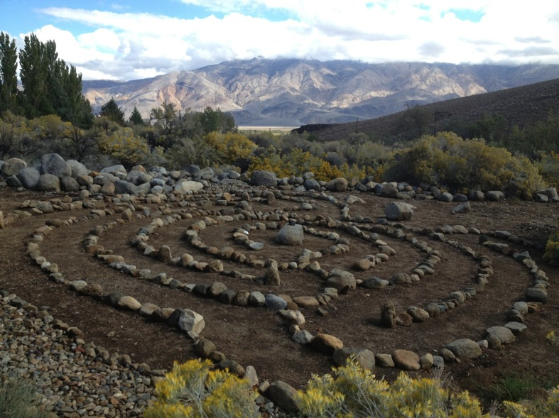

Our work continues -- to serve when called, to bear witness wherever we are, inside and out, to be with, turn into, and move through what is often reaction, grief, and anger to what is happening to our people, species, and places in the world. It is a vision, a practice, a necessity, a path, a responsibility, an opportunity and a blessing - to stay with and focus on the beauty, the love, care and connection. Our response has included sitting in council and ceremony at times, walking 200 miles with and for the water, building earthen structures as council huts, working with and teaching permaculture principals, offering rites of passage, wilderness quests for community leaders, supporting frontline activists and organizations in a variety of ways, being willing to go and willing to stay, listening always for where to be.

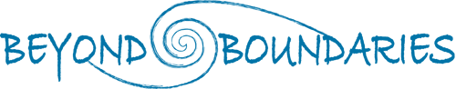

This year, 2015, we spent time and energy redesigning the website. We feel that even if people don’t visit an Ojai Foundation or a Tamera, or participate in a BB quest, just knowing that they, we, exist often provides courage, inspiration, a feeling of connection, and community.
Our work has included guiding, training, mentoring, supporting, and participating with both organizations and individuals here in the US and abroad, including
Youth Passageways, the School of Lost Borders, The Ojai Foundation, Biosphere Foundation, Weaving Earth, Tamera, Findhorn Foundation, Walking Water, The School of All Relations, Grace Foundation, European Council Network, and a new “Global Council Web” (soon to be officially named something else ), which highlights the practice of council and the re-emergence of circle ways everywhere we know.

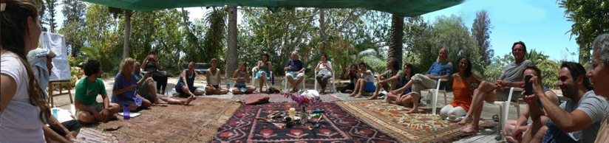

Our main projects/collaborations, where three or more Beyond Boundarians are leading the charge, have been:

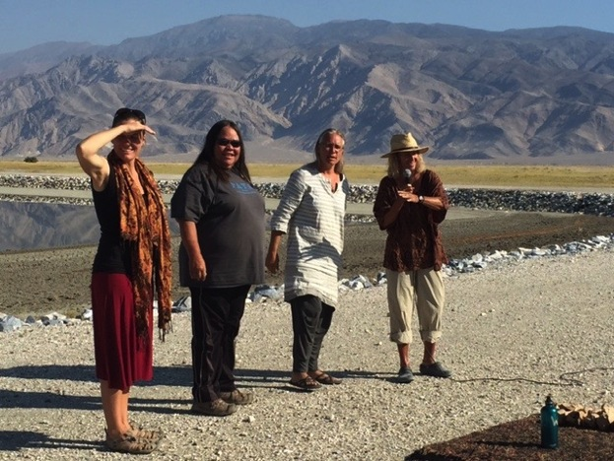

Walking Water
This is a three-year, three-phased pilgrimage in the Eastern Sierra, California, from ‘water’s source to end user’ -- Mono Lake to Los Angeles -- highlighting the need for all to be involved in our care of this life force. (see attached full report)

Three Creeks
We continue to offer this sanctuary as a place of incorporation and shared stewardship for our extended family, and pilgrims in service of the global village.
(see attached full report)

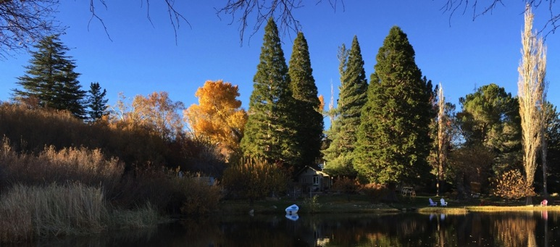

Council Hut Initiative
This year on the upper land of the Ojai Foundation an earth-bag council hut, one more beautiful place, was built to foster growth in our connection with self, each other, and the earth. This is a fulfillment of the dream to seed council there in kiva-like structures that began in the New Mexico kiva in the early 90’s when making The Box: Remembering The Gift. (see attached CHI report)

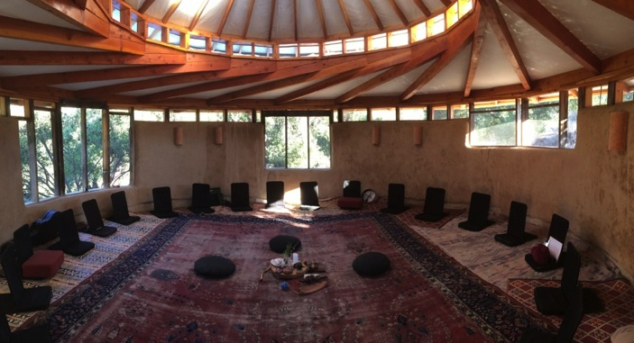

Earth Treasure Vase/Findhorn Foundation
The continuation of the New Story Summit in 2014, through the “carrying” and “burying” of an earth treasure vase on that land, with that local community, and the NSS/ETV community. (see attached ETV report)

Ripples
These named above are perhaps the most visible projects, programs, and products. Yet, we would be remiss not to name the many ripples, the many subtle, less visible effects of those carrying the work, practices, and spirit of Beyond Boundaries.

Our involvement with:
~Growing cooperation and collaborations with ‘watering holes’, particularly the communities of Tamera, School of All Relations (SOAR), Weaving Earth, and more. (See SOAR report below)
~Many councils in Turkey, Belgium, the Czech Republic, Indonesia, Portugal and beyond....as well as continuing to be part of the offering of council in schools, prisons, communities, businesses, and organizations.
~Councils, conversations, and connections amongst those in service responding to the refugee crisis, the reaction to Muslims, the floods and environmental crises in different regions of our planet.
~Next steps in offering the Nature of Council in different locations/watering holes, and expanding the inter-generational leadership of this course.
~Sewing seeds of the import of rites-of-passage for young people in many hearts primarily through work with Youth Passageways and the School of Lost Borders... along with the exploration of what it is to be an elder in the village, in our times.
~The presence and work of some of “our people” at the Climate Summit in Paris.
~The sharing of support and resources for the many we know going through health challenges, both mental and physical… especially with the rising epidemic of cancer.
~The growing strength of initiatives by key BB people including Will with Weaving Earth, Shay with Bioneers, Siri with the Global Campus, Aaron and Emilia with their baby and many ways of making music, our farmers Sam and Sierra and 10 more of us engaged this year in one way or another .....

As the Dalai Lama said, it takes Prayer and Action

In sum: BB continues to respond with care and attention to healing on the deepest levels, in ourselves, our families, our communities, with First Nation Peoples and “settlers” carrying our ancestral wounds, with refugees in our country for sure and beyond, social justice so needed everywhere, including in the natural world. Somehow carrying the simple yet profound prayer to live with awareness of the rights of all beings and all life. (See attached Statement of the Indigenous in Paris.)

Finances
This season marks the end of an official eight-year relationship with the Biosphere Foundation and a continuation of our respect and friendship in both old, and we suspect, new ways. They have been our fiscal umbrella organization, and we are blessed to have had their sponsorship and now celebrate the official completion of that relationship, knowing our bond, of course, goes way beyond the legal ties. We feel it is right timing for both of us.

A Biosphere Foundation Financial Report will be sent to our various sponsors and foundation grants at the end of January. In the meantime, let it be shared that our budget this year (including last year’s carry over) was approximately $100K. We consciously spent it all on the work described herein... you will see some of those costs spelled out in attached reports. We got a lot of bang for the buck, and hope you agree. (Full Financial Report available next month)

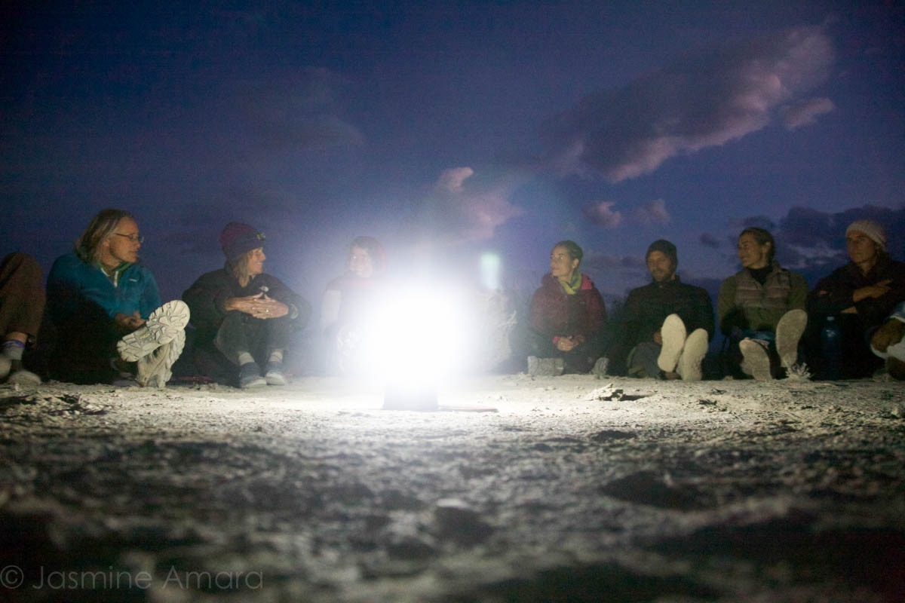

Futures
This coming year BB will continue many relationships and projects, including Phase 2 of Walking Water. Also new teams are coming together around council, ROP, healing biotopes and village charrettes. There is a request for and exploration of more council huts. Each of us will be responsible for making proposals, finding the right team, the right allies, the best sponsors and partners. We will keep our website up and running and current. At the end of the year we will again call for a report on all. Throughout the year mentorships and collaborations will continue and grow as we will respond to the needs/requests/callings that arise...our way is to respond
and not have so much administration and organizational oversight. More self-empowerment and responsibility, more self-generated accountability to the whole, more trust and taking initiative with good follow-through, more gifting economy. Speaking of which !!! Given the generous surprise gift of a long-time friend and co-heart, Win and I have received $25K to share as a flow fund that will assist in getting this year off to a fine start. Some of these funds will be coming to each one, which we entrust for all to move forward, in the spirit of our shared vision.

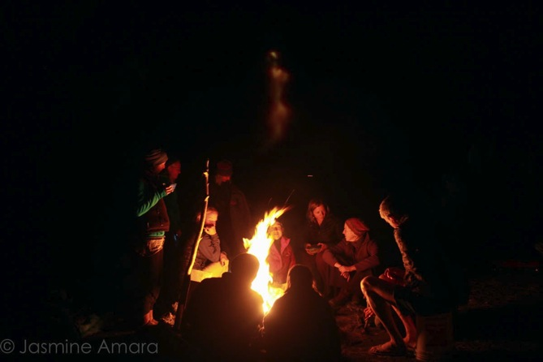

May we be good fire keepers

Deep gratitude for our partners, our allies, our teachers,
and our financial supporters....

May we continue to listen for our part in the whole, for the council, the ceremony, the activity that contributes to the beauty - a story and world we can all live in.
May our story of what has happened be a source of
inspiration and healing as much as the act itself... may this report be shared.

~~~

Please note - the unique expression and styles in the accompanying reports knowing that they too, along with all of the work, are BB collaborations. We want to acknowledge primary points and authors for these :
Shay for Earth Treasure Vase, Marlow for Council Hut Initiative, Win for Three Creeks, Rob for SOAR. And extra kudos to Siri, Sierra, Win, and yours truly for financial and admin work .....and for all who made the new BB website happen, especially Shay and Kate.

